Optimization-based Mechanisms for the Course Allocation Problem

Online Supplement

Appendix A. Market simulation details for the efficiency and the fairness results
We assume that the value of each course for each student is the combination of a field-specific value for course belonging to the field (or major plan of study), plus an independent course value for the student. This setup tends toward correlated preferences among students according to their interest in a field/major denoted $f$. Therefore, a value $V_{ij'}=\sum_{[∀f:j^{'}∊f]}{α_{fj'}}+ β_{ij'}$ is calculated, where the value $V_{ij'}$ of course $j'$ (considering all of its sections) for student$i$ is defined equal to $α_{fj'}$which is the random order of field$f$for student $i$ multiplied by 5 plus $β_{ij'}$ , a random number drawn from the normal distribution ($μ=10$, $σ=10$).
Then, the top $M_{1}$courses with highest$V_{ij'}$are selected from 83 courses for each student. $M_{1}$ is independently chosen for each student from the discrete uniform distribution on the interval [30, 35]. To generate correlated yet distinct values for particular sections of the same course, we generated random normal number $CS_{ilj'}$ for the $l^{th}$ section of each selected course $j'$of student$i$, and set the section value to $VS_{ilj'}=V_{ij'}+CS_{ilj'}$. For each student, all course-sections are sorted based on$VS_{ilj'}$ and the top $M1$course-sections are selected. Re-indexing course sections to a single list translates the $l^{th}$ section of each selected course $j'$to the index, and thus ${VS}_{ij}=VS_{ilj'}$ . The ordinal values of course $r_{ij}$ are the inferred based on ${VS}_{ij}$ to span the integers between [${100- M}_{1}+1, 100$]. Therefore, $r_{ij}$for student $i$‘s top course is 100, for her second favorite course is 99, and so on.
Finally, the $u_{ij}$ values of course-sections of each student are assigned as follows. Depending on the number of courses evaluated by a student, approximately 10% (and then 40%, 40%, 10%, respectively) of the courses receive a draw from a discrete uniform distribution [0,10] (and then [10,50], [50,100] and [100,200], respectively). For each student, these values are normalized to sum up to 1000 and then monotonically assigned as $u_{ij}$ values in the same order as the already assigned $r_{ij}$ values determined above.

Appendix B. Further incentive compatibility results when $w_{i}$ for truthful students is equal to 0, 0.25, 0.5, and 0.75, and when $P>20\%$.
In the first part of this appendix, we assume that $w_{i}$ of truthful students is 0, 0.25, 0.5, and 0.75 and show measurements similar to those shown in §5.3.

Figure B.1 – Strategic upside when $w_{i}$ for truthful students is 0

Figure B.2 – Strategic upside when $w_{i}$ for truthful students is 0.25

Figure B.3 – Strategic upside when $w_{i}$ for truthful students is 0.5

Figure B.4 – Strategic upside when $w_{i}$ for truthful students is 0.75

Figure B.5 – Strategic downside when $w_{i}$ for truthful students is zero

Figure B.6 – Strategic Downside when $w_{i}$ for truthful students is 0.25

Figure B.7 – The Strategic Downside when $w_{i}$ for truthful students is 0.5

Figure B.8 – The Strategic Downside when $w_{i}$ for truthful students is 0.75

Figure B.9 – The Net Benefit when $w_{i}$ for truthful students is zero

Figure B.10 – The Net Benefit when $w_{i}$ for truthful students is 0.25

Figure B.11 – The Net Benefit when $w_{i}$ for truthful students is 0.5

Figure B.12 – The Net Benefit when $w_{i}$ for truthful students is 0.75

For the second part of this appendix, we provide additional results for the main setup (i.e., when $w_{i}$ for truthful students is 0.5) but when the proportion of strategic students, $P$, varies.
Figure B.13 – Average changes in ordinal utility of strategic and truthful students under $P=40\%$
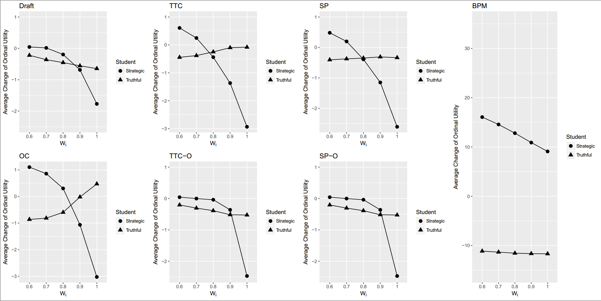

Figure B.14 – Average changes in ordinal utility of strategic and truthful students under $P=60\%$
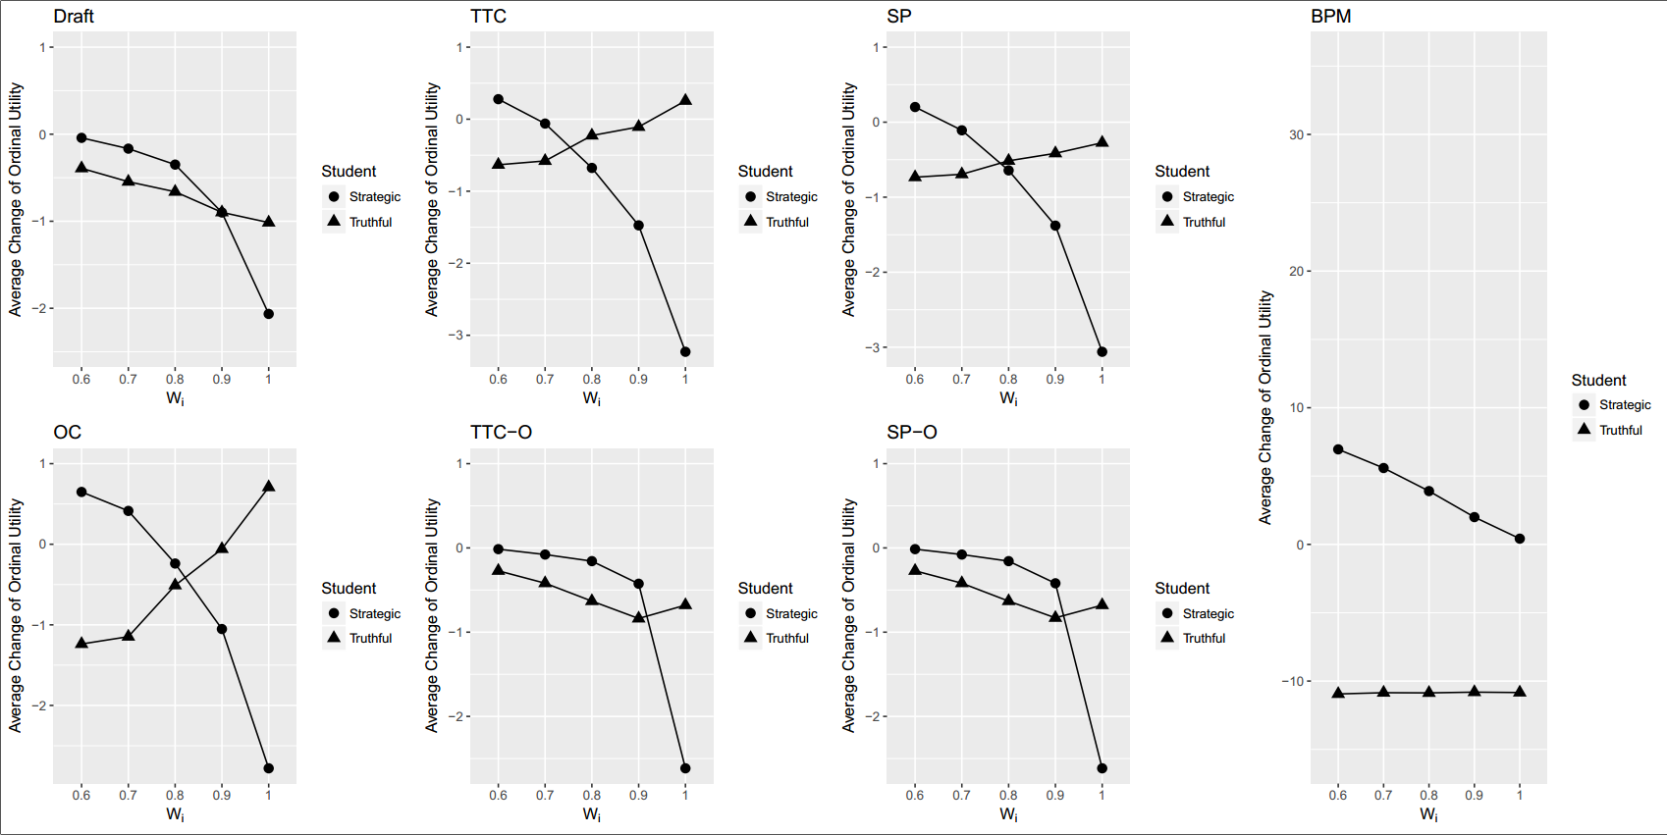

Figure B.15 – Average changes in ordinal utility of strategic and truthful students under $P=100\%$
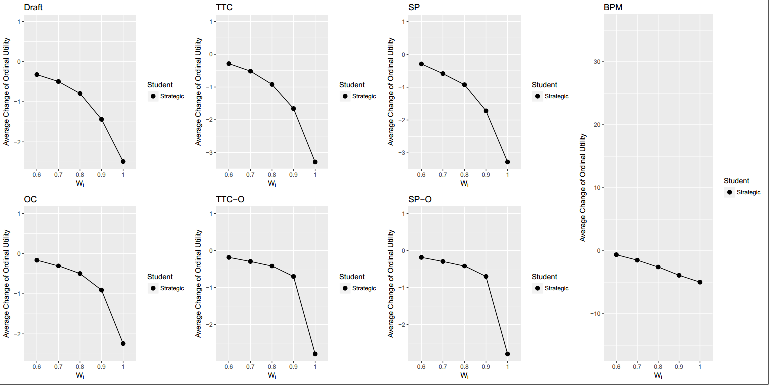

Figure B.16 – Top – Standard deviation of change in ordinal utility of strategic students with different$P$.
Bottom – Standard deviation of change in ordinal utility of truthful students with different$P$.
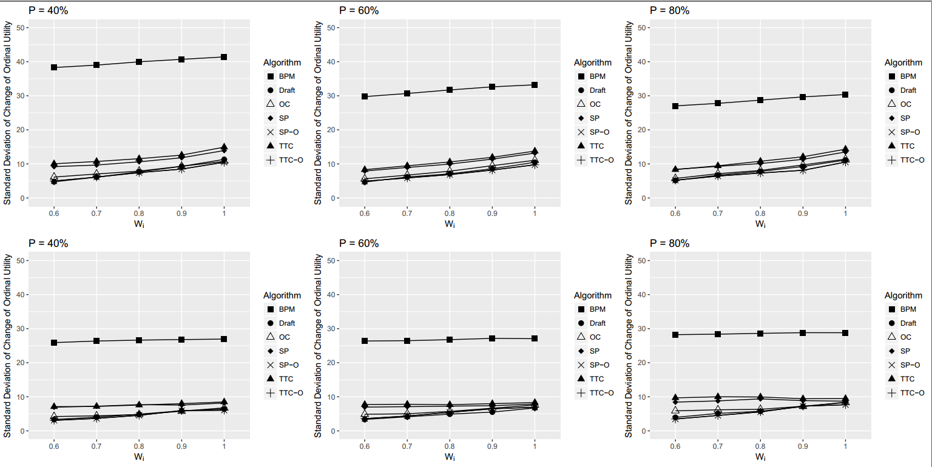

Appendix C. Comparison to the A-CEEI mechanism.
To compare the A-CEEI algorithm with the algorithms described here, we first found that the computational time burden of running that algorithm on the same size problems discussed in this paper was prohibitive. So we instead used the smaller setup of Othman et. al. (2011), but still, based on computation time we had to limit ourselves to just five market instances. Each of these markets includes $n=250$students and $m=50$courses. Each course has only one section and the possibility of course overlap was not considered. Also, each course has $q_{j}=27$seats and each student needs $k=5$courses. In each of these five cases, it was possible to run all seven algorithms described in the earlier figures of this paper in under 6 seconds, while a Tabu search implementation of A-CEEI consistently reached our 2-hour time limit without converging to a market clearing error below the defined threshold. Budish (2011) proved that the market clearing error threshold for each market is $\sqrt{(k×M)/2}$ which is equal to 15 in our experiments, though we could not achieve values lower than about 49.5 on average. This metric of infeasibility translated to an average of 119.4 seats assigned beyond the capacity (in total over several highly demanded courses) while simultaneously resulting in several courses with empty seats, totaling 131.2 unused seats on average (because their price was set too high.)
In short, we find quite poor performance for the A-CEEI method compared to the others discussed here. All algorithms assigned the max possible number of seats (50*5=1250 seats) to students except A-CEEI which assigned on average 12 seats fewer than other algorithms. Also, in all random trials, all algorithms except A-CEEI assigned exactly 5 courses to each student while in A-CEEI on average the worst student gets 2.2 courses. Accordingly, the average range of binary utility for all algorithms is zero while it is 2.8 for A-CEEI algorithm. Similarly, the average standard deviation of binary utility for all algorithms is zero while for A-CEEI it is 0.315.
Further results are provided as follows in Figures C.1 through C.6:
Figure C.1 - The average ordinal utility per student per algorithm, showing amounts above A-CEEI benchmark with average ordinal utility of 432.34 per student.

Because the Othman et al. (2011) setup is more competitive market, with total supply (50 * 27 = 1350 seats) not much more than total demand (250 * 5 = 1250), in most algorithm runs no student is awarded her best bundle. Here, the ordinal value of the best bundle is 490 points ($=100+99+98+97+96$).
Figure C.2 - The average range of ordinal utility per student per algorithm

Figure C.3 – Average standard deviation of ordinal utility per student per algorithm

Figure C.4 – The average cardinal utility per algorithm, amounts above A-CEEI benchmark with average cardinal utility 156.73

Figure C.5 – The average range of cardinal utility per algorithm

Figure C.6 – Average standard deviation of cardinal utility per algorithm

Appendix D. Comparisons on Random Instances, Varying the Common-Value Weighting for True Values.
In a final set of experiments, we followed the simpler simulation structure of Kominers et. al. (2010) to test the performance of the investigated algorithms in extreme cases. Similar to their model, each course only has one section and no field of study was defined. However, unlike their model, we maintained our assumptions of overlapping courses and that a student will not ranks all possible courses. Accordingly, to quickly view the performance of the mechanisms under varying degrees of common-value, equation (21) was used to define the true value of course $j$for student $i$.
$u_{ij}=(1-W)*v_{ij}+W*g_{j}$ (21)
In equation (21), $v_{ij}$ and $g_{j}$are independently selected from the standard normal distribution and $W$ was varied as a treatment parameter. When $W=1$, all students exactly bid equally for each course, while if $W=0$ students utilities for each course are totally independent. When $0<W<1$, student preferences are partially correlated in varying degrees. In our analysis, we compared algorithms in five conditions: $W$ equals to 1, 0.9, 0.5, 0.1, and 0.0. As $W$ increases, the correlation among student preferences increases and bid values and rank values of each course among students become more similar to each other.
Incentives were not considered in this set of experiments. Where §5 and Appendix C varied a personalized parameter $w_{i}$ (in equation 20) to capture manipulation of true values for a studied of incentives, here the single value $W$ is varied to change true preferences across the entire market. So here, rather than asking how manipulation affects outcome when some pretend to have a larger than truthful amount of common value, we ask how does the market as a whole perform when more or less common value is present in true valuations. For a further element of robustness, we drop some of the constructs of realism described in Appendix A, in which students have major fields of study. Here the focus is instead on more random instances, trying to see how well our algorithms perform under more extreme circumstances.

D.1 Binary Utility
Looking at Figure D.1, our results show that when $W$ is small (0 or 0.1) and student preferences over their top 30 to 35 courses are mostly random and uncorrelated to each other, each student did receive exactly 6 courses in all algorithms and in all 100 market instances therefore all algorithms could assign 5400 seats to students. When $W$ is equal to 0.5, the only algorithm which assigns all 5400 seats is OC while BPM misses the most seats in comparison to other algorithms, as before. When $W$increases to 0.9, the Draft mechanism assigns the lowest number of seats among different algorithms. Without ranking all courses (students only list their favorite 30-35 courses out of 83 available) assigning all seats becomes increasingly difficult for all algorithms as $W$ increases. As everyone’s preferences converge to the same favorite courses, it becomes impossible to assign courses that no one has asked for. As seen in Figure D.1, OC still achieves the best binary utility outcome, assigning the maximum number of seats among different algorithms. However, even OC cannot assign more than about half of offered seats as $W$ approaches 1.
Figure D.1 - The average total binary utility per algorithm for $0≤W≤1$.

D.2 Range of Binary Utility
As already noted, for small values of $W$such as 0 or 0.1 is exactly 0 since in these conditions all algorithms are able to assign 5400 seats to students and all students can take 6 courses. However, as $W$ increases not all algorithms are able to assign the maximum number of courses. When $W$is equal to 0.5, BPM achieves the highest range of binary utility and the most unfair solutions. These results reveal that in 99 instances of 100 instances BPM assigned 2 or fewer seats to the student with minimum number of courses while for OC this number is always 6. However, when $W$increases to 0.9 or 1, in each of our simulated market instances, there is at least one student who could not receive even one course based on OC algorithm. In these examples, the rank and bid of each specific course for all students is almost the same and the algorithm does not care to assign a specific course to a student who already has other courses or to a student with no course. As a result, when preferences are so correlated that less than full schedules are necessary, OC has no built-in safe guard to assign courses equitably. Thus, if OC were to be implemented in situations of extreme correlation additional constraints would be needed. In other words, when $W$ is large, we need to add constraints to OC to keep the number of courses among students similar in order to achieve similar results as in the more realistic (major-field of study based) simulations.
However, we expect not to face this issue in SP-O and TTC-O algorithms, based on the round-by-round methods’ explicit goal of equity. Our results confirm this expectation (see Figure D.2), and we see that when all preferences are (nearly) identical SP-O can achieve the fairest results and can be considered as the most reliable algorithm in achieving fair solutions.
Figure D.2 - The average range of binary utility per algorithm for $0≤W≤1$.

D.3 Ordinal and Cardinal Utility
When $W$ is small and student preferences are mostly uncorrelated to each other, again we find all algorithms performing similarly in average ordinal and cardinal utility per person with slightly better results for our proposed algorithms. As expected, OC which first maximizes total market ordinal utility always performs best on the average ordinal performance. When $W$increases to 0.5, OC and then TTC-O and SP-O achieve the most efficient solutions based on ordinal and cardinal utility while BPM is the most inefficient algorithm based on these metrics. When $W$ becomes close to 1, all algorithms perform similarly based on average ordinal and cardinal utility, as seen in Figures D.3 and D.4.
Figure D.3 - The average ordinal utility per student per algorithm for $0≤W≤1$.

Figure D.4 - The average cardinal utility per student per algorithm for $0≤W≤1$.

D.4 Range and Standard Deviation of Ordinal and Cardinal Utility
Our final set of results are shown in Figure D.5 through D.8, concerning the range and standard deviation as fairness metrics on utility. Where OC again dominates at the intermediate point in which $W=0.5$, consistent with the main results of the paper, these fairness results tend to vanish as the correlation grows. In its focus on achieving good ordinal and cardinal market performance, OC will randomly favor some students; with (nearly) identical students some must win and some must receive very poor (even empty) schedules in the best overall outcome. Still TTC-O and SP-O show that with only mildly worse overall performance, these ranges and standard deviations can be kept lower. These latter mechanisms are therefore seen to be more robust to extreme correlation with respect to fairness, converging toward a pure rationing outcome as students get closer to identical preferences.
Figure D.5 – The average range of ordinal utility per algorithm for $0≤W≤1$.

Figure D.6 – The average range of cardinal utility per algorithm for $0≤W≤1$.

Figure D.7- The standard deviation of ordinal utility per algorithm for $0≤W≤1$.

Figure D.8- The standard deviation of cardinal utility per algorithm for $0≤W≤1$.

