Mobile Targeting Using Customer Trajectory Patterns
Online Appendix

Anindya Ghose  aghose@stern.nyu.edu | Beibei Li  beibeili@andrew.cmu.edu | Siyuan Liu  sxl68@psu.edu
Stern School of Business  New York University | Heinz College  Carnegie Mellon University | Smeal College of Business  Penn State University

Online Appendix A. Technical Details on Mining Mobile Trajectories
In this appendix, we discuss how we automatically identify similar customers by mining the individual-level mobile trajectory data.
Step 1: Extracting Multi-Dimensional Mobility Features from Individual Trajectories
We first discuss how we characterize individual mobility by extracting unique movement features from the various dimensions of individuals’ mobile trajectories. Building upon prior theory and literature discussed in Section 2, we focus on four different dimensions of mobility features: temporal duration, spatial dispersion, semantic information, and movement velocity. Through these four mobility dimensions, we aim to capture similar patterns in individuals’ physical movement from different perspectives. Note that this step allows us to learn consumer behavior not only through static-locational or contextual proximity information, but also through dynamic movement similarity obtained from the underlying mutual interaction or shared relationship.
Temporal Duration
We define temporal duration as containing information on the starting and ending time of the mobile trajectory, as well as the day-of-the-week index. More specifically, for each consumer, we extract a vector with three different temporal features: the starting time of a consumer’s trajectory, the ending time of this trajectory, and the day index. These temporal features aim to capture the temporal activity pattern for real-life communities. To measure the similarity between two user trajectories in their temporal dimension, we adopt a similar approach as in Liu and Wang (2017), using a temporal kernel function.
Spatial Dispersion
Spatial dispersion measures the spatial alignment of different user trajectories. The close alignment of two trajectories might indicate high behavioral similarity between the two users. To compute the spatial closeness (“spatial similarity”) between two customers over time, we consider the spatial distance, altitude (floor level) and movement directions (compass degree from north).
Note that to account for the popularity of the location, we inversely weigh the spatial similarity in proportion to the crowdedness of a specific location. Intuitively, this approach is similar to TF-IDF in text mining (e.g., Manning et al. 2008). More specifically, our method builds on the Global Alignment Kernel (GAK) to measure the spatial similarity between two trajectories (Cuturi 2011). The intuition is to capture the spatial closeness between two individuals over time. However, the popularity of a location can potentially bias the GAK. For example, if customers A, B, and 100 other customers are waiting in a concourse area, the spatial closeness between A and B becomes less informative of the similarity between them, because this concourse is clearly a popular location for almost everyone. However, if A and B are the only two customers in the concourse, this spatial closeness can instead reveal significant information on the similarity between them. Based on this intuition, we apply the GAK with the Inverse Proportion method (GAK-IP), which weighs the spatial similarity in inverse proportion to how many other people are co-located within the nearby area.
Semantic Information
Semantic information aims to capture the contextual information related to the mobile trajectory. For example, it contains the stationary probabilistic distribution of individuals’ visits to different stores in the mall, the time spent at each store, the time spent in transit from one store to another, and the transition probability between two stores.
More specifically, our goal is to measure the traverse statistics on the sites and to use them to measure the semantic similarity of user trajectories. If L denotes the total number of spatially distinct sites, we can extract the following features of the sites visited by an individual user.
Markov state transition. We construct the Markov state transition matrix 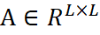, where 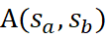 represents the transition probability from site to site . To calculate , we first collect all of the site transition pairs from the entire set of trajectories. Then, we count the number of occurrences of each transition pair. Finally, we perform column normalization of , satisfying 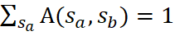.
Temporal intervals. We measure the time spent at each site and the time taken in transit from site to site to capture the “level of interest” shown by the users (e.g., when a shop is very “interesting,” the shoppers might choose to stay longer) as well as the convenience of moving from site to site , which indicates the semantic relation of the two sites.
Based on the semantic features extracted from the trajectories, we are able to compute the similarity between two user trajectories in their semantic dimension using the Histogram Intersection Kernel and the Radial Basis Function (RBF) Kernel (Liu and Wang 2017).
Movement Velocity
Finally, movement velocity contains information about the speed and acceleration of customers. The information encoded in the velocity pattern of customers is critical. However, we face two challenges when modeling the velocity pattern. The first challenge is that the overall length of each individual trajectory is different, which incurs difficulty in directly measuring their pairwise similarity in the velocity aspect. The second challenge is that even within the same individual mobile trajectory, velocity can vary largely at different times and locations; therefore, performing a direct measurement is difficult as well. To account for these challenges and to make velocity comparable across heterogeneous individual trajectories, we normalize the velocity by applying a temporal pyramid matching method. This method, as inspired by the normalization method, calculates the image similarity in image classification while accounting for the different scales of resolution (Lazebnik et al. 2006).

More specifically, to analyze the velocity similarity of the trajectories, we design a Temporal Pyramid Kernel by considering different temporal resolutions and non-uniform lengths of the individual trajectories. In particular, each trajectory is initially associated with a raw velocity vector with unequal lengths. Each value in the velocity vector is a speed value measured at a certain time. First, we uniformly quantize the velocity into L levels. Then, given a trajectory k and its initial velocity vector V_{k} with a specific length l_{k}, we calculate the normalized histogram h_{k}(0) on V_{k}. Then, we equally divide V_{k} into two parts V_{k} → [V_{k}(1) , V_{k}(2)], where both V_{k}(1) and V_{k}(2) are also velocity vectors with l_{k} /2. We then calculate the normalized histogram h_{k}(1) and h_{k}(2) on V_{k}(1) and V_{k}(2), respectively, and normalize them so that Σ h_{k}(1) + Σ h_{k}(2) = 1. Consequently, we further equally divide V_{k}(1) or V_{k}(2) into two parts again and calculate the histograms in the same way. Such process can be conducted recursively until a predefined level is achieved. Finally, we concatenate all the histograms with predefined weights.
For illustration, we provide in Figure A1 a toy example with a three-level temporal pyramid in the figure below. The three levels (i.e., 0, 1, 2) represent coarse to fine temporal resolutions, respectively. We assign weight of each level to be assigned with [1/4, 1/4, 1/2], where the bottom level is assigned with the highest weight (Liu and Wang 2017). Based on this method, we can extract a velocity histogram h_{k} of equal length with coarse-to-fine temporal resolution. The similarity between user trajectory k and k′ can be calculated with histogram intersection or Chi-Square kernel. Our Temporal Pyramid Kernel method is a much more refined matching method than using the simple average speed. It captures the distribution of the speed over the entire trajectory with a much smoother functional curve by taking into account different levels of temporal resolutions.
Figure A1. Example of A 3-Level Temporal Pyramid Kernel

Step 2: Measuring Pairwise Consumer Similarity from Multiple Trajectory Dimensions
Based on the four dimensions of mobility features extracted in Step 1, we are able to infer consumer similarity. Specifically, we calculate the pairwise similarity score between two consumers by combining the features as follows:
[A1]
where 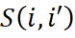 denotes the similarity of consumer and consumer , denotes the number of dimensions of mobility features (here = 4), 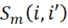 denotes the similarity in the m-th dimension of mobility features, and 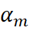 denotes the pre-assigned weights reflecting the specific interests of the problem domain. The similarity score in the m-th dimension of mobility features can be calculated using different similarity functions such as cosine distance, histogram intersection or chi-square kernel.
Step 3: Using Graph-based Clustering to Identify Groups of Similar Customers
Based on the pairwise similarity scores of consumers derived from the previous step, we can cluster similar individuals according to their pairwise similarities. The main goal of this step is to identify clusters of consumers wherein individuals are similar to each other with regard to their mobile trajectories but dissimilar to consumers not in the cluster.
Building on the literature, we use a graph-based clustering method to achieve our goal. In particular, we apply the Markov Clustering Algorithm (MCL) for dense sub-graph detection (Van Dongen 2000, Satuluri et al. 2010). This is an unsupervised learning method that allows for leveraging of a network structure to extract groups of similar items. MCL has several advantages (Satuluri et al. 2010) over distance-based clustering algorithms such as k-means and hierarchical clustering (Eisen et al. 1998). First, MCL relative to the k-means-based algorithm is less sensitive to the initial starting conditions. Second, MCL does not take any default number of clusters as an input; instead, it allows the internal structure of the network to determine the granularity of the cluster. Third, MCL, compared with many state-of-the-art network-clustering algorithms, is more noise-tolerant and effective at discovering the cluster structure (Brohee and Helden 2006).
More specifically, we first construct an undirected probabilistic graph of individual trajectories (an example is shown in Figure A2), where each node in the graph represents a consumer’s trajectory, and the weight on each edge between two nodes represents the pairwise similarity between two consumers. Therefore, if two consumers are very similar to each other in their trajectory patterns, the weight on the edge between the two corresponding consumer nodes would be very high. Our goal is to detect a set of highly connected sub-graphs from the graph where the weight on the edge between each pair of two nodes in the sub-graphs is relatively high (i.e., dense sub-graph). The basic intuition of the MCL algorithm is based on the idea of a random walk. The probability of visiting a connected node is proportional to the weight on the edge. In other words, the random walk will stabilize inside the dense regions of the network after many steps. The stabilized regions shape the clustered sub-graph and reflect the intrinsic structure of the network. The sub-graphs hence represent the identified clusters of similar consumers.
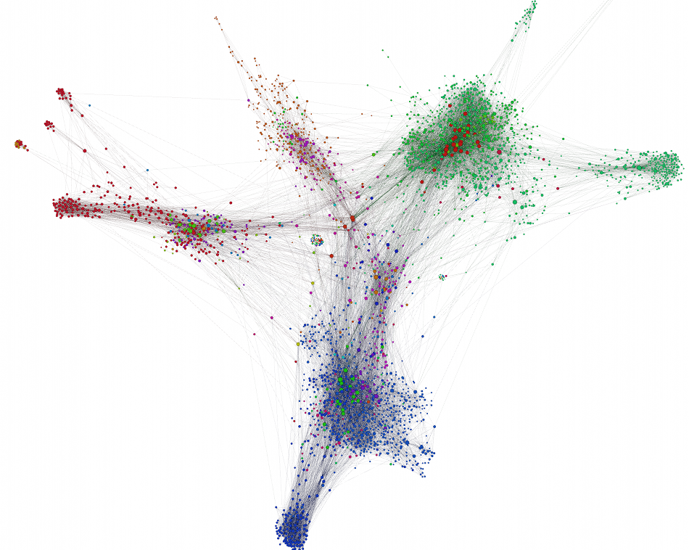
Figure A2. Example of Graph-Based Trajectory Clustering. The clustering method will find mutually exclusive partition groups of customers (sub-graphs), where within each group customers are similar to each other and between groups customers are different.

References:
- Brohee, S. and Jacques, V. H. 2006. Evaluation of Clustering Algorithms for Protein Interaction Networks. BMC Bioinformatics, 7 (1), 488.
- Cuturi, M. Fast global alignment kernels. In ICML’11.
- Eisen, M. B., Spellman, P. T., Brown, P. O., and Botstein, D. 1998. Cluster Analysis and Display of Genome-wide Expression Patterns. Proceedings of the National Academy of Sciences, 95 (25).
- Lazebnik, S., C. Schmid, and J. Ponce. Beyond bags of features:Spatial pyramid matching for recognizing natural scene categories. in Proc. IEEE Comput. Soc. Conf. Comput. Vis. Pattern Recognit. 2006.
- Manning, C. D., Raghavan, P., Schutze, H. 2008. Scoring, Term Weighting, and the Vector Space Model. Introduction to Information Retrieval. 100.
- Satuluri V., S. Parthasarathy, D. Ucar. 2010. Markov clustering of protein interaction networks with improved balance and scalability; Proceedings of the ACM Conference on Bioinformatics and Computational Biology. pp. 247–256. ACM.
- Van Dongen S. 2000. Graph clustering by flow simulation. PhD thesis, University of Utrecht, Netherlands.

Online Appendix B. Technical Details on Mobile Trajectory-based Recommendation
With the detected clusters of similar consumers from the previous steps, we then target mobile ads by offering recommendations to a consumer from stores that are most frequently visited by similar consumers. This approach is similar to the collaborative filtering approach widely used in traditional recommender systems.
In practice, recommendations are achieved by calculating the ratings of the consumers for the stores. More specifically, the rating of a consumer for a store is a measurement of one’s interest in that store. Following prior literature (e.g., Adomavicius & Tuzhilin 2005), we define the observed rating as whether or not a consumer has visited a store. Given consumer and store , one common approach to predict the rating 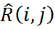 is to average the observed ratings of similar consumers on store j weighted by their similarity information. Thus, the predicted average rating can be calculated by
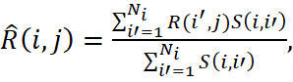 [B1]
where denotes the number of similar consumers to consumer , and 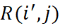 denotes the observed rating of consumer on store . Therefore, when generating the recommendation to consumer i, we will rank all of the predicted ratings between i and each store 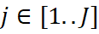 and recommend the store that shows the highest predicted rating for consumer i. Note that if the consumer has already visited this store in the past, we will choose the next best store on the ranking list.

References:
- Adomavicius, G. and Tuzhilin, A. 2005. Towards the Next Generation of Recommender Systems: A Survey of the State-of-the-Art and Possible Extensions. IEEE Transactions on Knowledge and Data Engineering, 17(6).

Online Appendix C. Technical Details on Data Collection and Indoor Localization
Data Collection
The data in this paper were collected via smartphone’s tracking of the WiFi network in the mall. Our technical methodology builds on previous work in wireless tracking and trajectory mining from computer science (e.g., Liu and Wang 2017, Guo et.al. 2014, Liu et al. 2013). More specifically, we provide more details of this collection process as follows.
At the entrance of the shopping mall, if a consumer would like to use the free WiFi (the free WiFi provided by the mall) we will collect the corresponding individual’s trajectory information. Note that we only use the WiFi of the mall to collect consumer trajectory information, and only SSID of the mall’s WiFi will be collected. The WiFi of the mall is dense enough (the access points are deployed around every 10 meters) to track the consumers in the mall in different stories.
When the consumer logs in the WiFi, she is required to fill a Form A (pop up when she tries to connect to the free WiFi) with information on age, gender, income range, credit card type (gold, platinum, gift card, others), phone type (iPhone, Android, others). At each store, when the consumer purchases a product, she is required to fill a Form B (sales in each store will ask her to do it during the purchase process) in store, which involves similar sociodemographic information plus whether the purchase is related to a mobile coupon and the amount of spending. We cross validate Form A and Form B to make sure the individual-level information is correct. In our experiment, we dropped those customers from our sample whose information from Form A and Form B was not consistent.
Once the consumer connects to the WiFi, we are able to in real time track the detailed mobile trajectory information during her visit in the shopping mall with precise time stamps. We leveraged RSS (Received Signal Strength) information, pre-trained signal strength map and SSID to localize each mobile phone, a.k.a., a person. The accuracy of localization is approximately 2 meters. For the transitions in Markovian state, each site (e.g., store) in the mall is defined much larger than a radius of 2 meters, hence can be very well captured in our WiFi localization.
Finally, when the consumer leaves the mall, we conduct a short follow-up survey asking whether she followed the mobile recommendation, whether she likes to follow such recommendations in future, overall satisfaction rate about the shopping experience, and additional personal information (e.g., first-time visitor or not, money spent in the focal advertising store, total money spent in the mall).
Indoor Localization
Each site (e.g., store) in the mall is defined much larger than a radius of 2 meters. Hence, it can be easily captured in our WiFi localization. Moreover, to improve the precision on detecting the boundary of the stores and to better capture store-profile information, we leveraged a crowdsourcing-based approach. In particular, aside from the mall free WiFi each store has its own secured WiFi for internal business use. Hence, we were able to pre-generate a heat map of all the WiFi signals in the mall beforehand. When a customer carries a mobile device into a store, even though she may not connect to the store-specific WiFi, the inertial sensor readings of the mobile device can still reflect the overlapping WiFi signals inside the store. Therefore, based on the pre-generated WiFi heat map, we were able to more precisely identify the customer’s location in the mall (e.g., near a store boundary) by matching the inertial sensor readings of the mobile device with the pre-generated WiFi heat map.

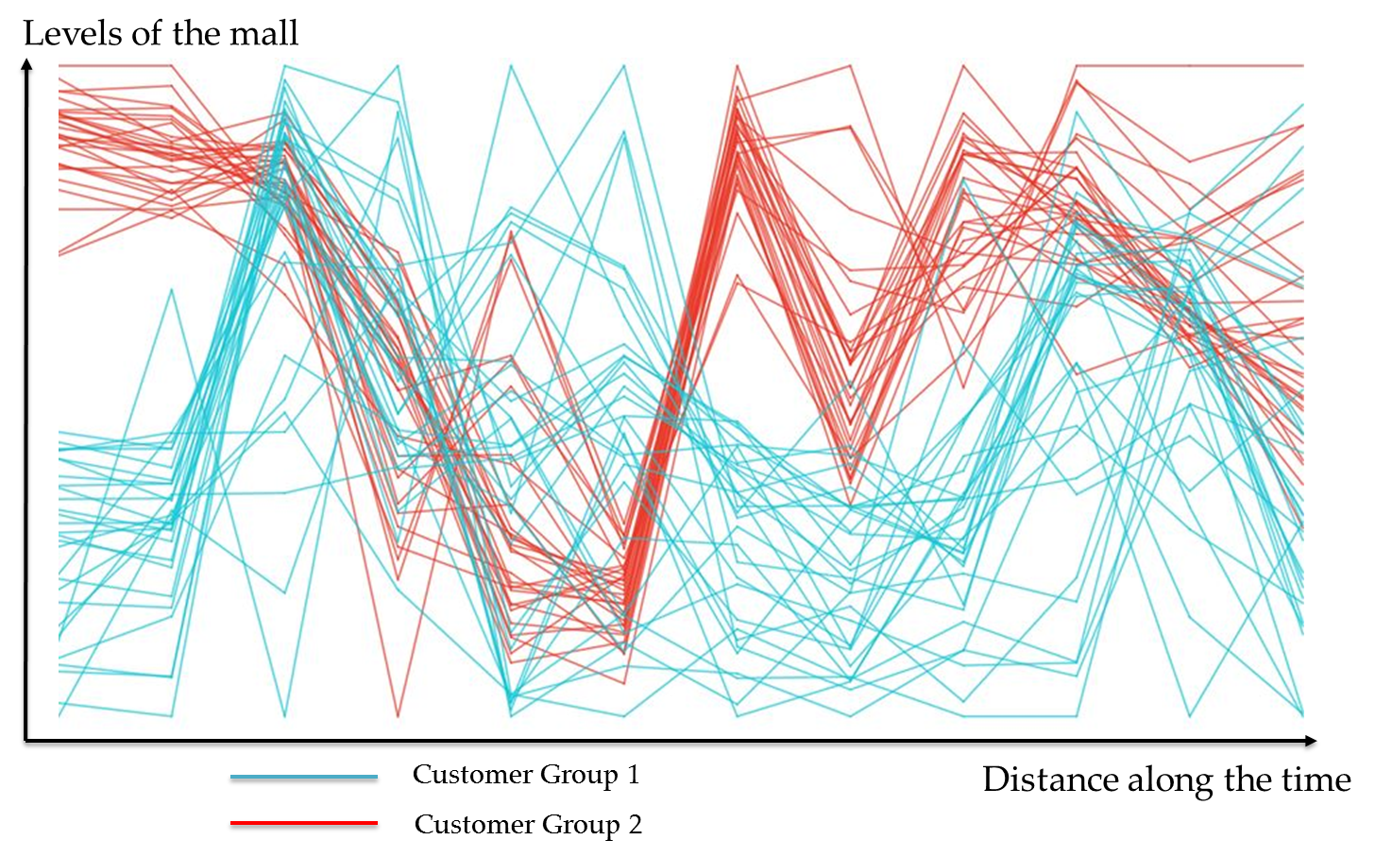
Figure C1. Example of Mobile Trajectories of Consumers in a Large Shopping Mall
Figure C1 visualizes an example of movement trajectories of individual customers traveling upstairs and downstairs in the shopping mall. Each line in the figure represents a trajectory from an individual consumer. The two colors represent two mobility clusters identified from our algorithm.

References:
- Liu, S., S. Wang. 2017. Trajectory Community Discovery and Recommendation by Multi-source Diffusion Modeling. in IEEE Transactions on Knowledge and Data Engineering.
- Guo, X., E. C. L. Chan, C. Liu, K. Wu, S. Liu and L. M. Ni. 2014. ShopProfiler: Profiling shops with crowdsourcing data. IEEE INFOCOM 2014 - IEEE Conference on Computer Communications, Toronto, ON, pp. 1240-1248.
- Liu, S., S. Wang, K. Jayarajah, A. Misra, R. Krishnan. 2013. TODMIS: mining communities from trajectories. In Proceedings of the 22nd ACM international conference on Information & Knowledge Management (CIKM '13). ACM, New York, NY, USA, 2109-2118.
Online Appendix D. Robustness Tests
To verify the robustness of our results, we conduct two sets of robustness tests to further account for the unobserved heterogeneity and to better interpret our findings: 1) store-level fixed effect and random effect to control for store-level heterogeneity; 2) separately conduct the group-level and individual-level analyses for each day to control for day-level heterogeneity. Overall, we find our results remain highly consistent.
Robustness Test I: Store-Level Heterogeneity Using Store-Level Fixed Effects and Random Effects
Different stores may provide different products, which may vary significantly in category, price, quality, brand affinity, and so on. In our experimental setting, we observe different stores, such as restaurants, cosmetics, supermarkets, and so forth. Randomization of store participation across different control and treatment groups in our experiment can alleviate such concerns to some extent, but potential store-level unobservables may still exist. For example, trajectory-based mobile ads could be more effective than random ads for cosmetics stores, though not necessarily for restaurants or supermarkets. To better control for the potential store-level unobservables, we conduct panel data analysis to examine daily revenues using a store-level fixed-effects model.
In particular, we model the overall revenues for store j on day t as a function of the number of different mobile ads sent by the store (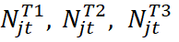), a weekend dummy, interaction effects, and a store-level fixed effect ():
[D1]
Table D1. Results from Store Fixed/Random Effect Models on Store Daily Revenues
Variables | Coefficient ^{Fixed-Effect} | Coefficient ^{Random-Effect}
# of Random Coupons | -0.1566 (.0092) *** | -0.1596 (.0091) ***
# of Location-based Coupons | 0.0140 (.0081) * | 0.0147 (.0080) *
# of Trajectory-based Coupons | 0.1562 (.0059) *** | 0.1566 (.0059) ***
Weekend | 0.9149 (.0735) *** | 0.9177 (.0735) ***
#Random × Weekend | 0.0287 (.0145) ** | 0.0288 (.0145) **
#Location × Weekend | -0.0060 (.0029) * | -0.0057 (.0029) *
#Trajectory × Weekend | -0.0346 (.0096) *** | -0.0343 (.0095) ***
*** P<0.001, ** P<0.05, * P<0.1
Total # of Observations: 14,112 (252 Stores * 14 Days * 4 Groups)
The estimation results from the store-level fixed-effects model are highly consistent with our previous findings from both group-level and individual-level analyses. The results from the store-level fixed-effects model are shown in Column 2 in Table D1. For a robustness test, we also consider a store-level random-effects model. We found the results from both fixed-effects and random-effects models stay very consistent. The results from the store-level random-effects model are shown in Column 3 in Table D1.
In particular, our analyses show that on average, trajectory-based mobile targeting has the highest positive effect on a store’s daily revenues after accounting for the potential store-specific unobserved factors. Meanwhile, store revenues are significantly higher during the weekends than during the weekdays. Interestingly, we find although trajectory-based ads become less effective during the weekends compared to the weekdays, it always outperforms other targeting strategies at store level. This result also supports our previous finding that the focal advertising store always benefits from well-designed mobile ads.

Robustness Test II: Ad-Category-Level and Ad-Level Matching to Further Control for Store-Level Heterogeneity
- Ad-Category-Level Comparison.

To look into the potential selection issue at store (ad) level, we first plotted the density distribution of ad categories served across all the three treatment groups (T1: Random-based; T2: Location-based; T3: Trajectory-based). In total, there are 15 categories of stores in the mall (Accessory, Bags, Dinning, Electronics, Entertainment, Fashion Clothes, Glasses, Household, Jewelry, Luxury, Personal Care and Cosmetology, Shoes, Sports, Grocery, Watch). Figure D1 below shows the density distribution of ads category served across the three treatment groups, where x-axis represents the store (ad) category ID and y-axis represents the frequency of category appearance. We find the distribution remains very similar across different groups.
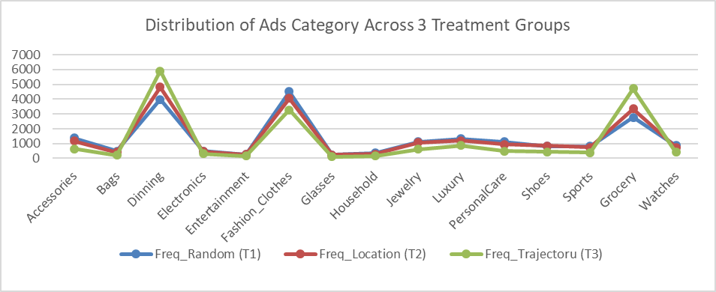
Figure D1. Distribution of Ad Categories Served in Three Treatment Groups.
To further quantify the similarity among the three distributions, we conducted a two-sample Kolmogorov-Smirnov (KS) test for pair-wise comparison between each two treatment groups. Our pair-wise two-sample KS tests show that the max cumulative difference (CumDiff) and the corresponding p-value (p) are the following:
T1 and T2: CumDiff = 0.0280, p = 0.226
T1 and T3: CumDiff = 0.0977, p = 0.181
T2 and T3: CumDiff = 0.0775, p = 0.197
Based on the p-values from the two-sample KS tests, we cannot reject the null hypothesis that the three ad samples were drawn from the same distribution of ad categories. In other words, we didn’t find significant difference in the distribution of the ad categories served among the three treatment groups. This empirical test suggests the “store selection bias” due to trajectory-based targeting is less likely a concern in our study. This is likely because of (1) the large size of the mall’s historical customer pool (i.e., with all customers’ mobility and purchase data over the past one year), which helped to generates recommendations with high precision; (2) the large sample size of customer population in our experiment (i.e., N_Random = 20,286, N_Location = 20,986, N_Trajectory = 21,490), which helped to cover significant heterogeneity in customer preferences. Hence, the collaborative-filtering-based recommendation was able to cover stores from a wide variety of categories (i.e., rather than focus on certain specific types of stores).

- Ad-Level Matching.

Although we find no statistical difference in the distribution of the ad categories among the three treatment groups, we did find difference in the distribution of the exact ads served among different groups. Because we have a total of 252 different stores (ads), it is quite expected that the distribution at the exact ad level may vary among groups. Figure D2 below shows the density distribution of the exact ads served across the three treatment groups, where x-axis represents the store (ad) ID and y-axis represents the frequency of ad appearance.
(a) T1 - Random (b) T2 - Location (c) T3 - Trajectory
Figure D2. Distribution of Ads (Pre-Matching) in (a) Random, (b) Location-based, (c) Trajectory-based Groups.
To further level the ad distribution across different treatment groups, we conducted two in-depth analyses based on: (i) Ad(Store)-Level Matching; (ii) Subsample Analysis. We discuss the former here and the latter next.
To match the distribution of ads between the Trajectory-based group (T3) and the two baseline groups (T1: Random-based; T2: Location-based), we conducted ads matching based on the ad distribution in T3 (e.g., Imbens 2004, Stuart and Rubin 2008). In particular, we sampled from T1 and T2 (respectively) based on the observed empirical distribution of the ads served in T3. We have tried sampling both with replacement and without replacement, and found the results are very similar. Figure D3 below shows the post-matching distribution of ads across the three treatment groups based on sampling with replacement, where x-axis represents the store (ad) ID and y-axis represents the frequency of ad appearance.
(a) T1 - Random (b) T2 - Location (c) T3 - Trajectory
Figure D3. Distribution of Ads (Post-Matching, Sample with Replacement) in (a) Random, (b) Location-based, (c) Trajectory-based Groups.
Based on the matched sample, we re-conducted the group-level and individual-level analyses. Our results indicate that after controlling for the distribution of the exact ads, our findings still hold consistently. Table D2 below shows the results from group-level analysis. Table D3 below shows the results from individual-level analyses for consumer redemption probability (Coefficient^{Redeem}), total spending at focal advertising store (Coefficient ^{AdStore}), and total spending at the mall (Coefficient ^{Mall}). Note that after matching the total sample size became N=85,078.
Table D2. Group-Level Results with Matched Samples (Daily Mean, 14-Day Period)
Group | Redeem Rate |  | Future Redeem Rate |  | Money Spent in Focal Store ($) |  | Total Money Spend in Mall ($) | Time Elapse Until Redeem | Satisfaction Rate | Time Spent in Focal Store (min) | Total Time Spent in Mall (min)
C –Control (n=1472) |  | -- |  | -- |  | -- | 84.98 | -- | 2.6 | -- | 46.75
T1-Random (n=1535) |  | 14% |  | 20% |  | 22.21 | 82.26 | 15.01 | 2.3 | 25.68 | 53.45
T2-Location (n=1535) |  | 21% |  | 31% |  | 40.03 | 170.12 | 10.41 | 3.4 | 14.98 | 66.07
T3-Trajectory (n=1535) |  | 31% |  | 56% |  | 56.78 | 193.06 | 4.55 | 4.3 | 9.82 | 71.98
P<0.05 (pair-wise t-test between each two groups)
Table D3. Individual-Level Results with Matched Samples
Variables | Coefficient^{Redeem} |  | Coefficient ^{AdStore} | Coefficient ^{Mall}
Random (T1) | −− |  | 2.3053(1.0001)** | 2.7043(.1202)***
Location (T2) | 1.7908(.0709)*** |  | 4.2986(1.0707)*** | 3.3378(.1004)***
Trajectory (T3) | 4.2164(.0922)*** |  | 8.1397(1.2062)*** | 4.0344(.2016)***
ShopperFocus | -5.3795(.0708)*** |  | -0.2875(.1759)* | -0.2475(.0741)***
Weekend | 0.0367(.0178)** |  | 1.1720(.4796)** | 1.1561(.0055)***
Afternoon | 0.4421(.0429)*** |  | 1.1857(.5002)** | 1.0114(.5008)**
Evening | 0.2483(.1102)* |  | 1.7285(.6221)** | 1.5300(.6226)**
FirstTimeVisitor | 0.0521(.0567) |  | 0.6238(.5017) | 1.1028(.8557)
Male | -0.1013(.0466)** |  | -0.7262(.3464)** | -0.7563(.0599)***
ln(Age) | -1.0456(.1361)*** |  | 0.0626(.2558) | 1.0164(.9503)
ln(Age)^2 | 0.2876(.0952)*** |  | 0.0051(.0126) | -0.0740(.1441)
ln(Income) | 0.7426(.8155) |  | -0.1609(.2651) | 1.0414(.2018)***
ln(Income)^2 | -0.0781(.1423) |  | 0.0728(.1228) | -0.1446(.0412)***
Credit Type |  | Yes | Yes | Yes
Phone Type |  | Yes | Yes | Yes
Shopping Context |  | Yes | Yes | Yes
Advertising Store Category |  | Yes | Yes | Yes
Coupon Type |  | Yes | Yes | Yes
Random × Weekend |  | −− | 0.2881(.1603)* | 0.8337(.1775)***
Location × Weekend |  | 0.0028(.0290) | -0.0292(.2025) | 0.0796(.1744)
Trajectory × Weekend |  | -0.1086(.0501)** | -0.1175(.2117) | -0.4417(.2098)**
Random × Male |  | −− | -0.0165(.0199) | 0.0425(.0788)
Location × Male |  | -0.0231(.0592) | -0.0216(.0234) | 0.0903(.0769)
Trajectory × Male |  | 0.1181(.0538)** | 0.0177(.0219) | 0.1058(.0468)**
Random × Income |  | −− | -0.0012(.0141) | 0.0256(.0285)
Location × Income |  | 0.0628(.0565) | 0.0698(.1080) | 0.0930(.0839)
Trajectory × Income |  | 0.0339(.0068)*** | 0.1887(.3356) | 0.2472(.0696)***
Random × FirstTimeVisit |  | −− | 0.0193(.0521) | 0.1622(.2216)
Location × FirstTimeVisit |  | -0.0703(.0923) | -0.0761(.0979) | -0.0559(.1996)
Trajectory × FirstTimeVisit |  | -0.0174(.0555) | -0.1321(.0856) | 0.0969(.1021)
Random × ShopperFocus |  | −− | -0.0128(.1067) | -0.1057(.0271)***
Location × ShopperFocus |  | 0.1621(.2658) | 0.1017(.2168) | 0.0537(.0382)*
Trajectory × ShopperFocus |  | 1.2213(.0871)*** | 0.3501(.1689)** | 0.3645(.0587)***
Total # of Observations |  | 64,470 | 85,078 | 85,078
*** P<0.001, ** P<0.05, * P<0.1

- Ad-Level Subsample Analysis.

In addition to matching the overall distribution of the ads, we also conducted a subsample analysis. In particular, we focused on a subsample of popular stores with high volume of sales – whose daily sales were ranked top 10 percentile (25 stores) among all stores. This lead to a subsample of N=27,342 observations of customer responses to ads from 25 stores.
Based on this subsample, we re-conducted the group-level and individual-level analyses. Our results demonstrate strong consistency with our main findings. Table D4 below shows the results from group-level analysis. Table D5 below shows the results from individual-level analyses for consumer redemption probability (Coefficient^{Redeem}), total spending at focal advertising store (Coefficient ^{AdStore}), and total spending at the mall (Coefficient ^{Mall}).
Table D4. Group-Level Results with Subsample of Popular Stores (Daily Mean, 14-Day Period)
Group | Redeem Rate |  | Future Redeem Rate |  | Money Spent in Focal Store ($) |  | Total Money Spend in Mall ($) | Time Elapse Until Redeem | Satisfaction Rate | Time Spent in Focal Store (min) | Total Time Spent in Mall (min)
C –Control (n=1472) |  | -- |  | -- |  | -- | 84.98 | -- | 2.6 | -- | 46.75
T1-Random (n=144) |  | 17% |  | 26% |  | 24.08 | 96.57 | 14.32 | 2.2 | 27.25 | 55.26
T2-Location (n=152) |  | 25% |  | 39% |  | 44.37 | 177.28 | 10.01 | 3.4 | 17.22 | 69.34
T3-Trajectory (n=185) |  | 37% |  | 63% |  | 59.51 | 201.55 | 4.23 | 4.5 | 11.96 | 75.61
P<0.05 (pair-wise t-test between each two groups)

Table D5. Individual-Level Results with Subsample of Popular Stores
Variables | Coefficient^{Redeem} |  | Coefficient ^{AdStore} | Coefficient ^{Mall}
Random (T1) | −− |  | 2.1223(.9921)** | 2.2035(.1357)***
Location (T2) | 1.3480(.1143)*** |  | 4.0049(.8876)*** | 3.0887(.1102)***
Trajectory (T3) | 2.0491(.1742)*** |  | 7.9695(1.3846)*** | 4.1408(.2345)***
ShopperFocus | -3.9242(.2346)*** |  | -0.2756(.1142)** | -0.2523(.0805)***
Weekend | 0.0349(.0196)** |  | 1.0103(.4536)** | 1.3674(.0064)***
Afternoon | 0.3987(.0688)*** |  | 1.3981(.3898)*** | 1.0026(.4801)**
Evening | 0.2219(.0611)*** |  | 1.5954(.5002)*** | 1.6980(.3321)***
FirstTimeVisitor | 0.0983(.1103) |  | 0.7866(.5570) | 1.5912(1.0251)
Male | -0.0807(.0364)** |  | -0.6453(.3008)** | -0.8127(.0768)***
ln(Age) | -1.0136(.3519)*** |  | 0.1221(.2872) | 1.2335(1.0205)
ln(Age)^2 | 0.2079(.1055)* |  | 0.0120(.0204) | -0.0629(.1585)
ln(Income) | 0.9928(.9052) |  | -0.2424(.3435) | 1.0167(.2113)***
ln(Income)^2 | -0.1002(.1276) |  | 0.0733(.1141) | -0.1683(.0375)***
Credit Type |  | Yes | Yes | Yes
Phone Type |  | Yes | Yes | Yes
Shopping Context |  | Yes | Yes | Yes
Advertising Store Category |  | Yes | Yes | Yes
Coupon Type |  | Yes | Yes | Yes
Random × Weekend |  | −− | 0.3241(.1203)** | 0.8112(.1557)***
Location × Weekend |  | 0.0035(.0302) | -0.0255(.1875) | 0.0762(.1898)
Trajectory × Weekend |  | -0.1107(.0463)** | -0.1098(.1991) | -0.4053(.1852)**
Random × Male |  | −− | -0.0112(.0182) | 0.0594(.0808)
Location × Male |  | -0.0336(.0449) | -0.0297(.0200) | 0.0972(.0743)
Trajectory × Male |  | 0.1402(.0689)** | 0.0165(.0343) | 0.1252(.0393)***
Random × Income |  | −− | -0.0011(.0102) | 0.0436(.0302)
Location × Income |  | 0.0291(.0357) | 0.0583(.1220) | 0.1001(.0887)
Trajectory × Income |  | 0.0514(.0120)*** | 0.2027(.3773) | 0.2555(.0701)***
Random × FirstTimeVisit |  | −− | 0.0282(.0489) | 0.1839(.2445)
Location × FirstTimeVisit |  | -0.0660(.0763) | -0.0834(.0887) | -0.0668(.1905)
Trajectory × FirstTimeVisit |  | -0.0237(.0462) | -0.1029(.0901) | 0.0865(.1276)
Random × ShopperFocus |  | −− | -0.0104(.0905) | -0.1224(.0338)***
Location × ShopperFocus |  | 0.2009(.3130) | 0.1141(.2223) | 0.0626(.0225)**
Trajectory × ShopperFocus |  | 1.5265(.3243)*** | 0.4245(.0968)*** | 0.3787(.0796)***
Total # of Observations |  | 6,734 | 27,342 | 27,342
*** P<0.001, ** P<0.05, * P<0.1

Robustness Test III: Day-level Heterogeneity
To test the robustness of our results, we conduct additional day-level analyses by separately conducting the group-level and individual-level analyses for each day. Our day-level separate analyses show high consistency with the pooled 14-day results. In particular, we find that on average, mobile trajectory-based ads outperform all strategies across all days. Meanwhile, we observe a significant decrease in the effect of the trajectory-based ads during the weekends, compared to the corresponding effect from the weekdays. By contrast, we observe a significant increase in the effect of the random ads during the weekends.
Robustness Test IV: Alternative Definition of “ShopperFocus” Stage
For robustness check, we also considered an alternative definition of ShopperFocus dummy variable that accounts for the velocity dimension.
In particular, we looked at the real-time speed of movement for each customer at CIM (Critical Intervention Moment). If the real-time speed at CIM is slower than the average speed of that customer during the entire shopping trip, we consider the customer as currently in a focused stage (ShopperFocus = 1) upon intervention. Otherwise, the customer is currently in an exploratory stage (ShopperFocus = 0) upon intervention. This definition was inspired by R3’s suggestion that when a customer spends longer time (hence incurring a slower walking speed) for a given store, it indicates his/her stronger purchase intent and focus.
Based on the new shopperFocus definition, we re-estimated our models for consumer redemption probability (CoefficientRedeem), total spending at focal advertising store (Coefficient AdStore), and total spending at the mall (Coefficient Mall). We found our results remain qualitatively very consistent. The corresponding results are provided in Table D6 below.
Table D6. Results Using Alternative Definition of ShopperFocus
Variables | Coefficient^{Redeem} |  | Coefficient ^{AdStore} | Coefficient ^{Mall}
Random (T1) | −− |  | 2.3321(1.0012)** | 2.8007(.1234)***
Location (T2) | 1.8082(.0711)*** |  | 4.3242(1.0709)*** | 3.3836(.1019)***
Trajectory (T3) | 4.2219(.0902)*** |  | 8.1514(1.2091)*** | 4.0396(.2166)***
ShopperFocus | -4.1420(.1164)*** |  | -0.4236(.1764)** | -0.3202(.0753)***
Weekend | 0.0368(.0151)** |  | 1.1872(.7895)* | 1.1771(.0059)***
Afternoon | 0.4549(.0442)*** |  | 1.2016(.5101)** | 1.0131(.5108)*
Evening | 0.2561(.1004)** |  | 1.7915(.6354)** | 1.6031(.6252)**
FirstTimeVisitor | 0.0505(.0602) |  | 0.6782(.5121) | 1.1160(.8668)
Male | -0.1032(.0470)** |  | -0.7896(.3756)** | -0.8587(.0661)***
ln(Age) | -1.0461(.1341)*** |  | 0.0684(.2658) | 1.0182(.9622)
ln(Age)^2 | 0.2932(.0969)*** |  | 0.0056(.0142) | -0.0843(.1344)
ln(Income) | 0.7577(.8152) |  | -0.1743(.2634) | 1.0473(.2190)***
ln(Income)^2 | -0.0795(.1416) |  | 0.0797(.1210) | -0.1639(.0417)***
Credit Type |  | Yes | Yes | Yes
Phone Type |  | Yes | Yes | Yes
Shopping Context |  | Yes | Yes | Yes
Advertising Store Category |  | Yes | Yes | Yes
Coupon Type |  | Yes | Yes | Yes
Random × Weekend |  | −− | 0.3131(.1820)* | 0.9588(.1781)***
Location × Weekend |  | 0.0028(.0288) | -0.0318(.2127) | 0.0912(.1766)
Trajectory × Weekend |  | -0.1103(.0555)* | -0.1279(.2220) | -0.5021(.2613)*
Random × Male |  | −− | -0.0179(.0180) | 0.0480(.0771)
Location × Male |  | -0.0231(.0587) | -0.0234(.0227) | 0.1029(.0772)
Trajectory × Male |  | 0.1209(.0544)** | 0.0186(.0256) | 0.1211(.0480)**
Random × Income |  | −− | -0.0018(.0118) | 0.0293(.0279)
Location × Income |  | 0.0642(.0556) | 0.0722(.1108) | 0.1055(.0869)
Trajectory × Income |  | 0.0347(.0062)*** | 0.2052(.3142) | 0.2801(.0749)***
Random × FirstTimeVisit |  | −− | 0.0189(.0512) | 0.1841(.2133)
Location × FirstTimeVisit |  | -0.0718(.0910) | -0.0726(.0994) | -0.0639(.1977)
Trajectory × FirstTimeVisit |  | -0.0181(.0569) | -0.1291(.0831) | 0.1103(.1013)
Random × ShopperFocus |  | −− | -0.0203(.1121) | -0.1224(.0266)***
Location × ShopperFocus |  | 0.1283(.2011) | 0.1135(.2457) | 0.0649(.0382)*
Trajectory × ShopperFocus |  | 1.0037(.0727)*** | 0.3571(.1842)* | 0.4417(.0601)***
Total # of Observations |  | 62,762 | 83,370 | 83,370
*** P<0.001, ** P<0.05, * P<0.1
Online Appendix E. Segment Profile among Different Trajectory-based Clusters
First, we zoom into each consumer segment identified from our trajectory-based clustering analysis described in Subsection 4.2. Our graph-based MCL algorithm has identified a total of 10 clusters among all our experimental users based on the similarity in mobility pattern. We label these clusters from Cluster 1 to Cluster 10. The demographic distributions of consumer age (Shopper_Age), income (Shopper_Income) and gender (Shopper_IsMale) across the 10 clusters are illustrated in Figure 2. Interestingly, based on pair-wise t-tests we found no statistical difference in the demographic variables among a majority of the trajectory-based clusters.
In particular, for each individual characteristic variables (Age, Income, Gender, ShopperFocus), we conducted pairwise t-test between each two clusters. Our results are shown below in Table E1. Overall, we found no statistical difference in these individual characteristics among a majority of the clusters. We did notice some clusters present significant difference in certain demographic variables compared to the others. For example, Cluster 1 and Cluster 5 both demonstrate significant difference in Age and Income from the rest of the clusters. However, the difference in demographic distribution is not salient among the majority of the clusters. This seems to suggest that the clustering results based on fine-grained trajectory data might have captured some additional unobserved heterogeneity of consumers beyond the traditional demographic dimensions such as age, income and gender.
Table E1. Pairwise t-Test for Comparison among Different Trajectory-based Clusters
Shopper  Income | Cluster1 | Cluster2 | Cluster3 | Cluster4 | Cluster5 | Cluster6 | Cluster7 | Cluster8 | Cluster9 | Cluster10
Cluster1
Cluster2 | **
Cluster3 | ** | ----
Cluster4 | ** | ---- | ----
Cluster5 | *** | * | * | *
Cluster6 | ** | ---- | ---- | ---- | *
Cluster7 | * | * | ---- | ---- | * | ----
Cluster8 | * | ---- | ---- | ---- | ** | ---- | ----
Cluster9 | ---- | * | * | ---- | * | ---- | ---- | ----
Cluster10 | * | ---- | ---- | ---- | * | ---- | ---- | ---- | ----
Results are based on pair-wise t-test. * P<0.1 ** P<0.05 *** P<0.001 ---- No Statistical Difference

Shopper  Age | Cluster1 | Cluster2 | Cluster3 | Cluster4 | Cluster5 | Cluster6 | Cluster7 | Cluster8 | Cluster9 | Cluster10
Cluster1
Cluster2 | *
Cluster3 | * | ----
Cluster4 | ---- | ---- | ----
Cluster5 | ** | * | * | *
Cluster6 | ** | * | * | * | ----
Cluster7 | * | ---- | ---- | ---- | ** | *
Cluster8 | ---- | ---- | ---- | ---- | ** | * | ----
Cluster9 | * | ---- | ---- | ---- | ** | * | ---- | ----
Cluster10 | ** | ** | ** | ** | * | * | * | * | *
Results are based on pair-wise t-test. * P<0.1 ** P<0.05 *** P<0.001 ---- No Statistical Difference

Shopper  Gender | Cluster1 | Cluster2 | Cluster3 | Cluster4 | Cluster5 | Cluster6 | Cluster7 | Cluster8 | Cluster9 | Cluster10
Cluster1
Cluster2 | ----
Cluster3 | ---- | ----
Cluster4 | * | ---- | ----
Cluster5 | ---- | ---- | ---- | ----
Cluster6 | * | ---- | ---- | ---- | ----
Cluster7 | * | ---- | ---- | ---- | ---- | ----
Cluster8 | ---- | ---- | ---- | ---- | ---- | ---- | ----
Cluster9 | ---- | ---- | ---- | ---- | ---- | ---- | ---- | ----
Cluster10 | ---- | ---- | ---- | * | ---- | * | * | ---- | ----
Results are based on pair-wise t-test. * P<0.1 ** P<0.05 *** P<0.001 ---- No Statistical Difference

Shopper  Focus | Cluster1 | Cluster2 | Cluster3 | Cluster4 | Cluster5 | Cluster6 | Cluster7 | Cluster8 | Cluster9 | Cluster10
Cluster1
Cluster2 | **
Cluster3 | ** | ----
Cluster4 | ** | ---- | ----
Cluster5 | ---- | ** | ** | **
Cluster6 | ** | ---- | ---- | ---- | **
Cluster7 | ** | ---- | ---- | ---- | ** | ----
Cluster8 | ** | ---- | ---- | ---- | ** | ---- | ----
Cluster9 | ** | ---- | ---- | ---- | ** | ---- | ---- | ----
Cluster10 | ** | ---- | ---- | ---- | ** | ---- | ---- | ---- | ----
Results are based on pair-wise t-test. * P<0.1 ** P<0.05 *** P<0.001 ---- No Statistical Difference

Author names are in alphabetic order.
In this study, we obtain the weight using two different approaches. First, we assume an equal weight of 0.25 for each dimension. Alternatively, we are able to learn the weight using machine-learning methods. In particular, we construct a training data set by manually rating the overall pairwise similarity between two trajectories on a scale from 0 to 1. Then, we use logistic regression to learn the corresponding weights based on the training set. For model evaluation, we use 10-fold cross-validation to avoid overfitting. We find the two approaches give us very consistent results. Hence, in our experiment, we applied equal weights to the four mobility dimensions.

